Facade
(Structural)

The façade pattern is a structural design pattern that provides a simplified interface to a complex system.
It has two purposes:
- Hides complex business logic from client code.
- Decouples subsystem code from client code. This allows changes within the subsystem without affecting the client code.

Here are a few usages of this pattern:
- Encapsulate logic and details of an app for clearness and security.
- Simplify access to a behind-the-scenes legacy system.
- Build a public API, such as a microservice API.
- Decrease network requests – a remote client makes one call to the façade, while the façade makes multiple calls to the underlying system.

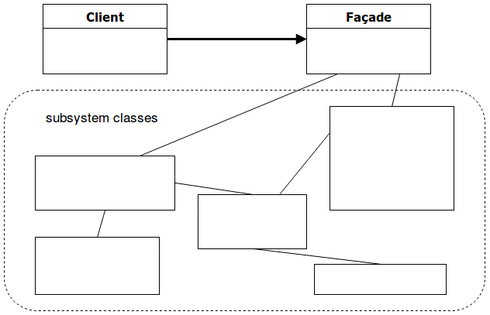

Pros
Below is a list of advantages of this pattern:
- loose coupling – the client has no knowledge of the subsystem.
- maintainability – changes are more manageable.
- simplicity – complexity is reduced by grouping related methods together, triggering them from a single, encompassing method.
Cons
A disadvantage of this pattern would be:
- runtime performance and code complexity – both can be negatively impacted if methods are unnecessarily wrapped in a façade. This leads to useless layers in the architecture.
In the following example, I provide a Java implementation of the façade pattern.
Let’s say you want to speculate in Bitcoin. This would be a fairly complex business process involving other hypothetical classes such as BitcoinWallet or BankAccount.
The CryptocurrencyFacade class simplifies this workflow by letting you call the investInBitcoin() method.

Step 1
public class CryptocurrencyFacade {

public void investInBitcoin() {
getBitcoinWallet();
chooseBitcoinExchange();
selectPaymentMethod();
buyBitcoinsAndStoreInWallet();
rideTheRollerCoaster();
}

}

Step 2
// How to call the façade:
CryptocurrencyFacade myFacade = new CryptocurrencyFacade();
myFacade.investInBitcoin();

Resources:
https://dragonprogrammer.com/design-patterns-java-simple-factory/

